**LAB 8**

Q1) Write an assembly code to convert the number 12438765h to 87654321h

**Program:**

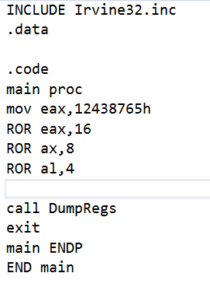

;K190207 Sara Jamal

**Output:**

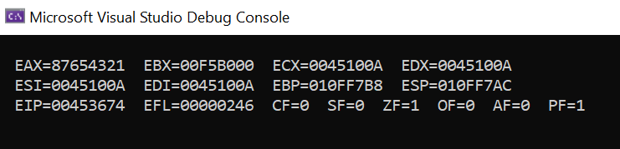

**Handwork:**

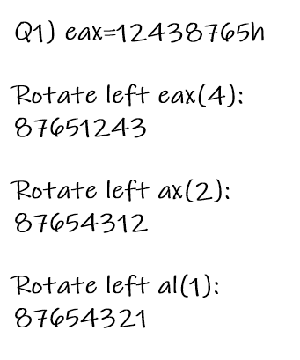

Q2) Write a program that shifts multiple bytes

.data

Byte1 byte 36h

Byte2 byte 26h

Byte3 byte 1Fh

**Program:**

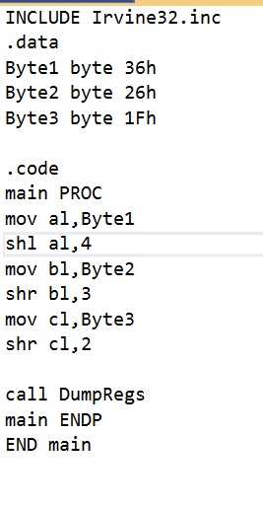

**Output:**

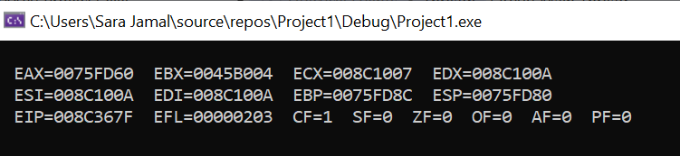

Q3) Write instructions to do divide 3142 and put the quotient in AX.

**Program:**

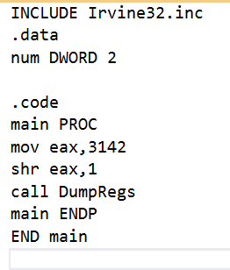

**Output:**

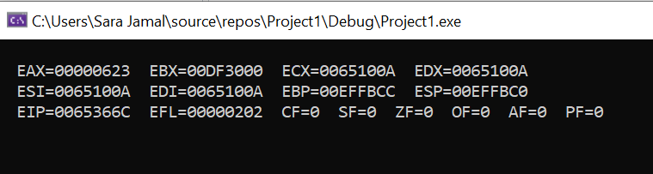

Q4) Suppose AL=11001011b and CF=1, give the new contents of AL

• ROR AL,CL ; CL=3

• SAR AL,CL; CL=2

**Program:**

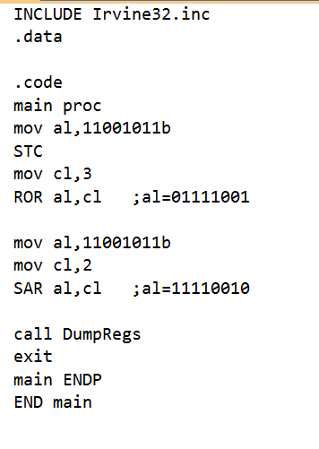

;k190207 Sara Jamal

**Output:**

**After ROR:**

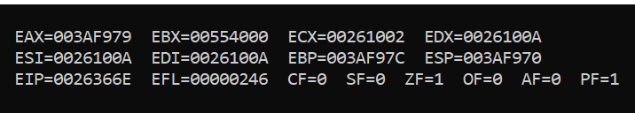

**After SAR:**

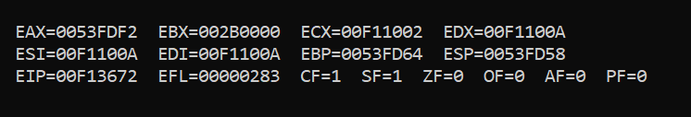

**Handwork:**

